TOPIC #1: Challenging Authority & Political Revolutions
Are Political Revolutions Worth the Risk?

GLOBAL I: Laying the Foundation for Understanding
The Enlightenment Challenging Authority

GLOBAL II: Constructing the Topic (Essential Questions)
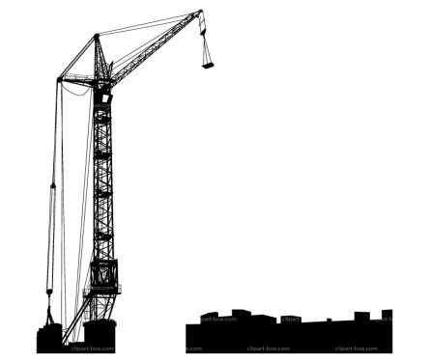

1- Describe how the Industrial Revolution changed daily life, becoming a turning point in history.
____________________________________________________________________________________________________________________________________________________________
2- Describe the factors that led to the Industrial Revolution beginning in Great Britain.
____________________________________________________________________________________________________________________________________________________________
3- What were conditions like in the new factories?
____________________________________________________________________________________________________________________________________________________________
4- Describe life in the new industrial city.
____________________________________________________________________________________________________________________________________________________________
5- How did the conditions of the early industrial age improve?
____________________________________________________________________________________________________________________________________________________________
6- Describe the views of laissez-faire economists like Adam Smith.
____________________________________________________________________________________________________________________________________________________________
7- Describe Karl Marx’s view of history and the ideology of communism.
____________________________________________________________________________________________________________________________________________________________8- Why did the ideas of Charles Darwin cause controversy?
____________________________________________________________________________________________________________________________________________________________
9- How did Charles Dickens explore realistic themes in his writing?
____________________________________________________________________________________________________________________________________________________________

Important Terms | Important People
Global I -  Global II - | Global I -  Global II -

Did the Benefits of the Industrial Revolution Outweigh the Costs? Use specific examples from class and specific terms from the topic to answer this question.
_____________________________________________________________________________________________________________________________________________________________________________________________________________________________________________________________________________________________________________________________________________________________________________________________________________________________________________________________________________________________________________________________________________________________________________________________________________________________________________________________________________________________________________________________________________________________________________________________________________________________________________________________________________________________________________________________________________________________________________________________________________________________________________________________________________________________________________________________________________________________________________________________________________________________________________________________________________________________________________________________________________________________________________________________________________________________________________________________________________________________________

