TOPIC 9: Russian Revolution: 1917-1939

Important Terms
- proletariat - soviet - commissar
- command economy - collective - totalitarian state
- atheism - Bolsheviks - Five-Year Plan
- Great Purge - NEP (New Economic Policy)

Important People
- Karl Marx - Czar Nicholas II - Rasputin
- Vladimir (V.I.) Lenin - Joseph Stalin

Essential Questions
1- What were the causes of the March Revolution (Bolshevik Revolution)?
__________________________________________________________________________________________________________________________________________________________________________
2- How did Lenin adapt Marxism to conditions in Russia?
__________________________________________________________________________________________________________________________________________________________________________
3- Describe the opposing forces (Whites vs. Reds) in the Russian civil war.
__________________________________________________________________________________________________________________________________________________________________________
4- How did Lenin make a compromise between the ideas of capitalism and communism in his NEP?
__________________________________________________________________________________________________________________________________________________________________________
5- What were the goals and results of Stalin’s five-year plans?
__________________________________________________________________________________________________________________________________________________________________________
6- What were the causes and effects of the Great Purge?
__________________________________________________________________________________________________________________________________________________________________________
7- What methods did Stalin use to create a totalitarian state?
__________________________________________________________________________________________________________________________________________________________________________

Overview
Rule under Czar Nicholas II and the extreme hardships of World War I set the stage for revolution in Russia. After they came to power, Lenin and the Bolsheviks tried to establish socialism and a dictatorship of the proletariat. They also had to rid their country of rival forces and rebuild a nation ruined by World War I.
V.I. Lenin directed the establishment of the Soviet Union under the authority of the Communist Party. In economics, Lenin mixed capitalism with socialism (mixed economy). After Lenin’s death, Joseph Stalin gained power through ruthless measures. Stalin’s economic goals were industrialization and collectivization. By launching the Great Purge and other acts of terror, Stalin gained absolute power.
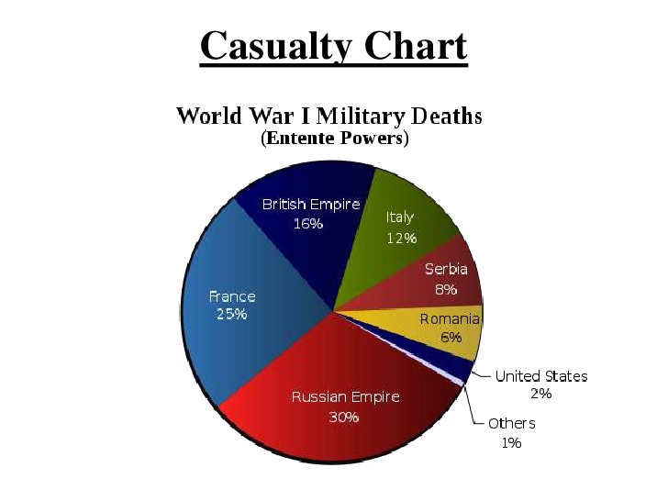
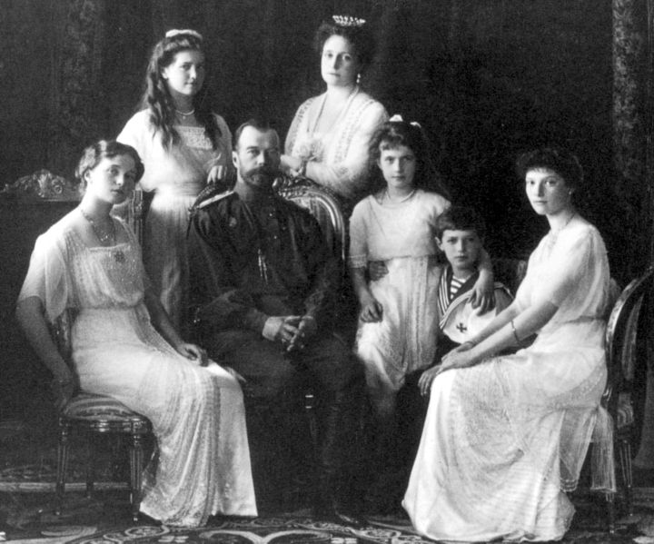

Lenin’s NEP (New Economic Policy) | Stalin’s Five-Year Plan
Mixed Economy:  - Peasants allowed to sell surplus crops.  - Some private businesses allowed to operate. Gov’t controlled heavy industry.  - Standard of living increases for peasants. | Command Economy:  - Gov’t confiscates all crops & livestock.  - Emphasis on heavy industry. Consumer goods are neglected.  - Land is collectivized; quotas set for production.  - Industries grow at the expense of the peasants. Famine and disease prevalent.

